Eg: Switch_Case_Eg11
//go through the program

Eg: Switch_Case_Eg12
//go through the code

Eg: Switch_Eg13

❌ Not allowed in switch
switch (true) // boolean ❌
switch (1.2f) // float ❌
switch (3.14) // double ❌
switch (10L) // long ❌

✅ Allowed in switch
byte
short
char
int
enum
String (Java 7+)

⭐ One-line exam takeaway
Java switch supports only byte, short, char, int, enum, and String;
it does NOT support boolean, float, double, or long.

Eg: Switch_Eg14
// go through the code

Eg: Switch_Eg15
// go through the code

Eg: Switch_Eg16
// go through the code

Eg: Switch_Eg17
// go through the code

Eg: Switch_Eg18
// go through the code

Eg: Switch_Eg19

⭐ Java switch Case Syntax Rules (Colon vs Arrow)

🔹 1️⃣ Traditional switch (Colon : syntax)
switch (fruit) {
case "APPLE":
System.out.println("Apple");
break;
case "MANGO":
System.out.println("Mango");
break;
default:
System.out.println("Any fruit");
}
Rules:
- If colon (:) is used:
  - ✅ ALL cases and default MUST use :
  - ❌ Mixing : with -> is NOT allowed
- break is required to avoid fall-through.

🔹 2️⃣ Enhanced switch (Arrow -> syntax, Java 14+)
switch (fruit) {
case "APPLE" -> System.out.println("Apple");
case "MANGO" -> System.out.println("Mango");
default -> System.out.println("Any fruit");
}
Rules:
- If arrow (->) is used:
  - ✅ ALL cases and default MUST use ->
  - ❌ Mixing -> with : is compile-time error
- No break is needed (no fall-through).

❌ Mixing is NOT allowed
switch (fruit) {
case "APPLE": System.out.println("Apple"); // ❌
case "MANGO" -> System.out.println("Mango"); // ❌ compile-time error
}

⭐ Final Exam-Ready Rule (keep this)
In a Java switch, all case labels must use the SAME syntax.
If : is used, all cases use :.
If -> is used, all cases use ->.
Mixing both causes a compile-time error.

Eg: Switch_Eg20
// go through the code

Eg: Switch_Eg21
// go through the code

⭐ Java Ternary Operator
- The Java Ternary Operator is used as a one-line replacement for the if–else statement.
- It is widely used in Java programming for simple conditional logic.
- It is the only conditional operator in Java.
- It works with three operands.

🔹 Syntax
condition ? expression1 : expression2;
- If the condition is true, expression1 is executed.
- If the condition is false, expression2 is executed.

🔹 Example
int a = 10, b = 20;
int max = (a > b) ? a : b;

⭐ One-line summary (exam-ready)
The ternary operator is a compact form of if–else and is the only operator in Java that uses three operands.

✅ What does operands mean?
Operands are NOT only variables.
👉 Operands can be:
- variables
- literals
- expressions
- method calls (that return a value)

🔹 In ternary operator
condition ? expr1 : expr2;

Operands are:
- condition → an expression that returns true or false
- expr1 → any value-producing expression
- expr2 → any value-producing expression

✅ Examples

✔ Variables as operands
int max = (a > b) ? a : b;

✔ Literals as operands
int x = (10 > 5) ? 1 : 0;

✔ Expressions as operands
int y = (a > b) ? a + 10 : b + 20;

✔ Method calls as operands
int len = (str != null) ? str.length() : 0;

⭐ Correct note sentence (keep this)
Operands can be variables, literals, expressions, or method calls — not only variables.

Eg : Teranary_Operator
// go through the code

Eg: Nested_Ternary_Operator
// go through the code

Eg: Ternary_Operator_Eg2
// go through the code

Eg: Ternary_Operator_Eg3
// go through the code

Eg: Ternary_Operator_Eg4
// go through the code

Eg: Ternary_Operator_Eg5
// go through the program

If Conditional statement:
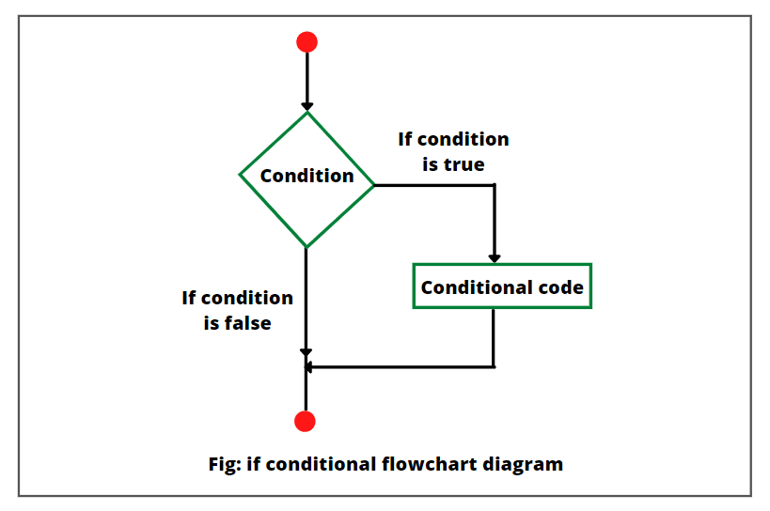

🔹 What is an if conditional statement?
- The if statement is used to execute a block of code only when a condition is true.
- If the condition is false, the code inside the if block is skipped.

🔹 How it works (as shown in the flowchart)
1️⃣ Program execution starts
2️⃣ The condition is evaluated
3️⃣ If the condition is true
→ Conditional code is executed
4️⃣ If the condition is false
→ Conditional code is skipped
5️⃣ Execution continues with the next statement

🔹 Syntax
if (condition) {
// code executes only if condition is true
}

🔹 Example
int x = 10;

if (x > 5) {
System.out.println("x is greater than 5");
}

🔹 Important Rules (note-ready)
- The condition must return boolean (true or false)
- Curly braces { } are optional for a single statement
- if does not require else
- If the condition is false, the if block is completely skipped

⭐ One-line exam summary
The if statement executes code only when its condition evaluates to true; otherwise, it skips that code.

Eg: If_Else_1
// go through the code

Eg: If_Else_If_Ladder_2
// go through the code

Eg: If_Else_3
// go through the code

Eg: If_Else_4
// go through the code

Eg: If_Else_5
//go through the code.

Eg: If_Else_6
// go through the code

Eg: If_Else_7
// go through the code

Eg: If_Else_8
//go through the code

Eg: If_Else_9

✅ Semicolon (;) is a valid Java statement
In Java, a semicolon by itself represents an EMPTY STATEMENT.
;
✔ This is syntactically valid
✔ It means “do nothing”

🔹 Example in if
if (true);
This is interpreted as:
if (true) {
// empty statement
}
So:
- The condition is evaluated
- No code is executed

🔹 Where this matters (very important)
if (x > 10);
System.out.println("Hello");
❌ Logical mistake
✔ System.out.println("Hello"); executes always, not conditionally

Eg: If_Else_10
// go through the code

Eg: If_Else_11
// go through the code

Eg: If_Else_12
// go through the code

Eg: If_13
In
b1 = false | ( b1 & b3 ) | ( b1 | b2 )
we reassigned b1 = false,
then why is b1 treated as true in (b1 & b3)?

✅ Correct explanation (very important rule)

🔹 Rule 1: Assignment happens LAST
In Java:
- The right-hand side (RHS) expression is evaluated first
- Only after the RHS is fully evaluated, the result is assigned to b1
So this line:
b1 = false | ( b1 & b3 ) | ( b1 | b2 );
means:
1️⃣ Evaluate
false | ( b1 & b3 ) | ( b1 | b2 )
2️⃣ After getting the final result
👉 assign that result to b1

🔍 Step-by-step evaluation (correct)
Initial values:
b1 = true
b2 = false
b3 = true
Now evaluate RHS:
false | ( b1 & b3 ) | ( b1 | b2 )

Step 1:
(b1 & b3) → true & true → true

Step 2:
(b1 | b2) → true | false → true

Step 3:
false | true | true → true

🔄 Final step (assignment)
b1 = true;
So:
- b1 was true during RHS evaluation
- b1 becomes true again after assignment

⭐ Key rule (NOTE-READY — keep this)
In an assignment expression, the RHS is evaluated completely using the OLD values, and only then the result is assigned to the LHS variable.

Eg: If_14

🔹 break
✔ Allowed in:
- loops
- switch
- labeled blocks
- labeled loops
label1: {
break label1; // ✅ allowed
}

🔹 continue
✔ Allowed ONLY in:
- loops
- labeled loops
❌ NOT allowed in labeled blocks
label2: {
continue label2; // ❌ compile-time error
}
Reason:
👉 continue means “go to next iteration”
👉 Blocks do NOT have iterations.

✅ Final correct note (use this)
break can be used in loops, switch, and labeled blocks.
continue can be used only in loops or labeled loops, not in labeled blocks.

⭐ One-line exam takeaway
break exits a block or loop; continue skips to the next loop iteration — so it works only with loops.

Eg: If_15
//go through the code

Eg: If_Else_16
//go through the code

Eg: Label_break

1️⃣ Normal break and continue (NO label)
These work only inside the current loop.

break
👉 Immediately stops the current loop.

continue
👉 Skips the current iteration and moves to the next iteration of the same loop.

Example (single loop)
for(int i = 1; i <= 5; i++){
if(i == 3){
break;
}
System.out.println(i);
}
Output:
1
2
✔️ Here, normal break is enough.

2️⃣ Problem comes with nested loops
When we have loops inside loops, normal break and continue affect only the inner loop, not the outer one.

Example (nested loops, NO label)
for(int i = 1; i <= 3; i++){
for(int j = 1; j <= 3; j++){
if(j == 2){
break;
}
System.out.println("i=" + i + ", j=" + j);
}
}
What happens?
- break stops only the inner loop (j)
- Outer loop (i) continues
✔️ Sometimes this is NOT what we want.

3️⃣ Why we need labeled break / continue
👉 To control OUTER loops from inside INNER loops
Labels give a name to a loop, so we can tell Java:
“Break or continue THAT loop, not this one.”

4️⃣ Labeled break

Example
outer:
for(int i = 1; i <= 3; i++){
for(int j = 1; j <= 3; j++){
if(j == 2){
break outer;
}
System.out.println("i=" + i + ", j=" + j);
}
}
Output:
i=1, j=1
✔️ break outer;
- Stops both inner and outer loops
- Control jumps outside outer loop

5️⃣ Labeled continue

Example
outer:
for(int i = 1; i <= 3; i++){
for(int j = 1; j <= 3; j++){
if(j == 2){
continue outer;
}
System.out.println("i=" + i + ", j=" + j);
}
}
Output:
i=1, j=1
i=2, j=1
i=3, j=1
✔️ continue outer;
- Skips remaining inner loop
- Moves to next iteration of outer loop

6️⃣ One-line difference (VERY IMPORTANT)
Statement | What it controls
break | Stops current loop only
continue | Skips iteration of current loop only
break label | Stops specified outer loop
continue label | Continues specified outer loop

7️⃣ When should you use labels?
✔️ Use labels ONLY when:
- You have nested loops
- You need to exit or skip outer loop directly
❌ Avoid labels in simple loops (not needed)

⭐ Final confirmation sentence (perfect for exams / interviews)
Labeled break or continue is used when we want to control a specific outer loop from inside a nested loop.

Eg: If_Else_Eg17
// go through the code

Eg: If_Else_Eg18
// go through the code

